City Of Calgary.
GCP Landing Zone Design & Implementation Document
Version 1.0
Document tracking
Revision history
Version | Author(s) | Description
1.0 | Gavin Singh | Initial Document

Reviews and approvals
Version | Reviewer(s) | Comments

Table of contents
Table of contents 3
1 Introduction 5
1.1 Executive Summary 5
1.2 Scope 5
1.3 Document Note 6
2 Key architectural decisions 7
3 Cloud Identity 8
3.1 Cloud Identity overview 8
3.2 IAM design and implementation 9
4 High Level architecture overview 10
4.1 High Level Architecture 10
5 Cloud identity and access management 10
5.1 Cloud Identity Overview 10
5.2 Domains 11
5.3 Super Admin 13
5.4 Service Accounts 13
5.5 Single Sign On 13
5.6 User Management 13
5.7 External Users 13
5.8 IAM Roles 13
5 Cloud identity and access management 10
5.1 Cloud Identity Overview 10
5.2 Domains 11
5.3 Super Admin 13
5.4 Service Accounts 13
5.5 Single Sign On 13
5.6 User Management 13
5.7 External Users 13
5.8 IAM Roles 13
6 Billing 14
6.1 Billing Account Overview And Design 14
6.2 Budget Alerts Overview and Design 14
6.3 Billing Exports 15
7 resource hierarchy 17
7.1 Organization & Resource Hierarchy Overview 17
7.2 Naming Convention 18
7.3 Labels 19
7.4 Resource hierarchy Design 19
7.5 Organization Policies Implementation 20
7.6 VPN design 21
8 networking 21
81 Regions 21
8.2 Network Configuration 22
8.3 External IP Requirements 22
8.4 Cross Project Communication 22
8.5 VPC Design 22
8.6 VPN Design 22
9 Monitoring and Logging 21
9.1 Cloud monitoring overview and design 21
9.2 Cloud logging overview and design 22
9.3 Labels 22
9.4 Resource Hierarchy design 22

10 networking 23
Security command center overview and design 23
9 Google Cloud VMware Engine 24
9.1 GCVE Management Network 24
9.2 VMware Engine to VPC connectivity 24
9.3 Cloud VMware Engine IAM roles 25
10 Infrastructure as Code 25
10.1 Repositories 24
11 security 25
11.1 Security Command Center Overview 24
12 Acronyms 26
13 Acknowledgement of Implementation 26

- Introduction
1.1 Executive Summary
This document provides the detailed Landing Zone design & implementation for City Of Calgary for Google Cloud Platform. The objective is to detail the infrastructure and security architecture of the landing zone as well as document the key decisions and rationale which supports the overall design.
The intended audiences of this document are Architects, Security Architects and Cloud Engineers, to support the implementation of the landing zone.

1.2 Scope
Here are the scopes of this project regarding the design and implementation of landing zone:
- Cloud Identity and Microsoft Entra Integration
Establish cloud identity foundation by integrating Microsoft Entra ID with Google Cloud Platform to enable centralized authentication and user management for the City of Calgary.
Key Deliverables:
- Cloud Identity Setup - Configure Cloud Identity as the identity provider for the GCP organization, establishing the foundation for user authentication and access management.
- Domain Consolidation - Migrate 20 existing suspended unmanaged Google accounts into the managed calgary.ca domain structure to ensure centralized control and compliance.
- Single Sign-On (SSO) Implementation - Configure federated authentication between Microsoft Entra ID and Google Cloud Identity, allowing users to authenticate once and access GCP resources using their existing corporate credentials.
- Automated User Provisioning - Implement SCIM-based provisioning to automatically synchronize user accounts, groups, and attributes from Entra ID to Cloud Identity, ensuring lifecycle management (create, update, suspend, delete) happens automatically.
- Licensing Configuration - Use Cloud Identity Premium licenses for Google workspace (No Productivity tools)

- Landing Zone Infrastructure Deployment
Deploy a secure, scalable GCP foundation using Infrastructure as Code (Terraform) and Google Cloud Landing Zone blueprints to automate environment provisioning.
Key Deliverables:
- Organization Hierarchy Design - Establish the GCP Organization node and implement a logical folder structure that aligns with the City's organizational units, governance requirements, and workload segmentation needs.
- Project Provisioning - Create initial GCP projects with appropriate configurations, quotas, and API enablement to support development, testing, and production workloads.
- Service Account Framework - Deploy service accounts with least-privilege permissions for application authentication and workload identity management across projects.
- Billing Integration - Link the City of Calgary's billing account with the Google Cloud Partner reseller account to enable consolidated billing, cost tracking, and budget management.
- Resource Management Controls - Implement organization policies, resource constraints, and hierarchical configurations to enforce governance, compliance, and operational standards across all GCP resources.
- Observability Configuration - Enable Cloud Logging, Cloud Monitoring, and Cloud Audit Logs with appropriate retention policies and log routing to support operational visibility and security monitoring.
- Security Baseline Implementation - Configure foundational security controls including Security Command Center enablement, organization policy constraints, and IAM baseline permissions.
- Infrastructure as Code Execution - Deploy the complete landing zone using Terraform-based blueprints, ensuring repeatable, version-controlled, and auditable infrastructure provisioning that follows Google Cloud best practices.

- Document Note
At the time of writing, the architect has made assumptions regarding information technology knowledge and skill level of the audience reviewing this document. This document refers to terms, acronyms, and specialized product jargons; where it is relatively brief to do so, these items are defined or expanded in-line with the text and context of the subject matter presented. Longer definitions and explanations can be found in the Acronym section.

- Key architectural decisions
Organization structure | A single organization is used for all environments and services for the City of Calgary to manage all resources and policies in one place.
Organization structure | The folder hierarchy has a single layer, consisting of fldr-coc-bootstrap, fldr-coc-billing-exports, fldr-coc-dev,fldr-coc-prod,fldr-coc-shared folders to allow for segregation of policies, privileges, and access.
Organization structure | Google Cloud organization policies are used to augment the organization's security posture by defining resource configuration constraints that apply consistently across all projects.
Resource deployment | Terraform is used as the infrastructure as code (IaC) tool.
Resource deployment | The IAC deployment's actions are initiated from the work-station environment.
Resource deployment | Terraform state is stored in the bkt-terraform-landingzone cloud storage bucket in the prj-coc-bootstrap project.
Identity and IAM | Azure AD is the source of truth for user provisioning and management, users are federated with Cloud Identity.
Identity and IAM | Cloud IAM roles are assigned to groups instead of individuals.
Identity and IAM | Users are synced from Azure AD, but permissions are assigned in GCP IAM
Networking | Shared VPC is used as the primary networking topology to enable centralized management of firewall rules and connectivity. Shared VPC we will create a proof of concept VPC. As of now we don't have any use case
Networking | No custom firewall rules were created for controlling network traffic flows.
Logging | Org-level log sinks are used to aggregate logs with severity level warning or above.
Logging | Aggregated logs in a folder with severity warning or above are sent to a centralized Cloud Log Bucket.
Detective Controls | Security Command Center standard is enabled to detect infrastructure misconfigurations, vulnerabilities, and active threat behavior.
Billing | Centralize billing into one account connected to Google partner or Self managed billing account.
Billing | One budget alert is created on a per folder basis with thresholds set at 75%, 90%, 100%, and 120% of last month’s spent.
- High-level architecture overview
  - High-level architecture
Here is the purposed architecture for GCP landing zone
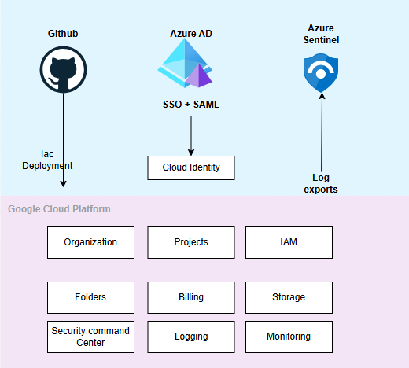
Figure 4.1.1: City Of Calgary GCP Landing Zone
Microsoft Azure AD is connecting with GCP cloud identity using SSO and SAML protocols. This means all users are authenticating through Azure AD first, then getting access to GCP resources through Cloud Identity. This is giving centralized control over who can access what in GCP.
GitHub is storing all Terraform code. CI/CD pipelines are out of the scope. Currently the operator will manually execute the terraform code which will deploy the organization landing zone services, Github URL link is <>

Azure Sentinel is receiving exported logs from GCP. This is providing centralized security analytics, threat detection, and compliance monitoring across the hybrid cloud environment. All security events are being analyzed in one place.
Inside Google Cloud Platform, the landing zone is establishing these core services:
- Organization - Top level structure for managing everything
- Projects - Separate workspaces for different teams or applications
- IAM - Identity and access management policies
- Folders - Organizing projects into logical groups
- Billing - Cost tracking and management
- Storage - Data storage solutions
- Security Command Center - GCP native security monitoring and management tool
- Logging - Capturing all Audit activity logs,systems logs etc
- Monitoring - Tracking system performance and health

- Cloud Identity and Access Management
  - Cloud Identity Overview
Cloud Identity is an Identity as a Service (IDaaS) solution offered by Google that centrally manages users and groups. It can be configured to federate identities between Google and other identity providers, such as Okta, Active Directory, and Azure Active Directory. Cloud Identity configurations are made in the Admin Console.
There are two types of user accounts in cloud identity, consumer accounts are user accounts with domains which are unmanaged like Gmail.com, and managed accounts belong to an organization and are controlled by its administrators. User accounts in cloud identity use a primary email address for identification. However, managed accounts can also have an alias email address and a recovery email address, these email addresses cannot be used for sign in but may be used for account-related actions. The domain of the primary email address must correspond to the domain of a Cloud Identity in a Google Workspace account.
The City of Calgary uses Microsoft Entra ID (Azure AD) as its primary identity provider. Entra ID federates with Google Cloud Identity using SSO and SAML protocols, enabling City employees to access GCP resources with their existing corporate credentials., City of Calgary will utilize “calgary.ca” as the primary login domain.
Table 5.1.1. City of Calgary current Azure AD configuration
Active Directory Setup
Domains exist in active directory? | Yes
Are the on-premises Active Directory domains synchronized with Microsoft Entra ID | Yes
Users Provisioning
Common identifiers for users?  (a) Email addresses  or  (b) User Principal Names (UPNs) | Email Addresses
Are all users part of the group?  Individual users that need to be provisioned? | No
How many domains are used by email address? | 1
Are there any users that exists in both ~ Google Workspace & Azure-AD? | Need to check
Do you have unmanaged users with domains like onmicrosoft.com? | no
Groups Provisioning
Groups are provisioned by?  (a) By Email address (team@company.com )  or  (b) By name? (Marketing Team) | name
How many domains used by email address? | 1
Do you plan to provision all groups to Google Cloud or only a select subset of groups? | Currently a subset
Does SSO needs to be enabled for all users? | Yes, subset of group

  - Domains
The City of Calgary environment consists of one primary Active Directory (AD) domain with separate forests/sub-domains/OUs for internal and extranet access. GCP Cloud Identity supports multiple domains, which can be added as secondary domains or domain aliases. Currently, we are only implementing calgary.ca as the primary domain in Cloud Identity. No secondary domains or aliases are being added at this time.
More detail on Domain verification steps are provided in Cloud identity implementation guide.doc

  - Super Admin
Google Cloud Identity Super Admins can set permissions for themselves and others at the organization level. Super Admins also can reset any password, effectively gaining access to any account. In alignment with best practices, City of Calgary will designate primary and backup super admin account holders. The accounts will be generic (composed of random letters and numbers for ambiguity) and only used in out-of-band changes or emergencies. These accounts bypass any SSO in place.
Super Admin accounts leverage Google Identity MFA mechanism since it will not be tied to Azure AD’s SSO. It is recommended that a physical key is added to the Super Admin accounts to ensure two-step verification. Passwords can support up to 100 characters and should follow City of Calgary existing corporate password policy for complexity and length.
More detail on implementation of super admin accounts is provided here section <> of this document <>
Table 5.3.1. City of Calgary current Super Admins
Super Admin ID
<gcp-random-characters>@calgary.ca | Primary Super admin user
<gcp-random-characters>@calgary.ca | Secondary Super admin user
  - Service accounts
A service account is a special kind of account used by an application, it is a non-human account. Applications use service accounts to make authorized API calls, authorized as either the service account itself, or as Google Workspace or Cloud Identity users through domain-wide delegation.
To maintain a security posture on the creation and use of service accounts the following two paths will be adopted:
- Service accounts are created by Infrastructure as Code pipelines to execute tasks or be assigned to workloads.
- Service accounts are created by a declared group of users with permission to create service accounts

By default, every project will include a newly provisioned default SA account which can be disabled, however separate service accounts will be provisioned for workloads deployed to the project with only the required permissions. This will allow granular permission control for each workload separately.

  - Single Sign On
Google Identity supports provisioning and management of identities through 3rd party identity providers such as Azure AD and others. Based on the City of Calgary requirement for a centrally managed identity, the design approach is to leverage Azure AD to provision and maintain the identities.
Azure AD will function as the source of truth for all identities within Google’s systems. Identities will not be able to be added/removed through Google Identity directly. Identities added to Azure AD will be provisioned automatically to Google’s, while identities that are removed will be removed from Google’s. This keeps identities in sync and provides a single management interface for identities.
Steps to implement SSO is provided here in section <> of this document <>

  - User Management
Leveraging Azure AD as the identity provider for Google Identity, Azure AD will provision and provide authentication to users that are authorized to access Google services.
Selected users and groups and synchronized (one way) from Azure AD to Google Identity to ensure all users provisioned in Azure AD can sign into Google services (including GCP). This process also ensures that accounts are disabled once an account in Azure AD is deleted/disabled.
Any user who authenticates with the organization’s domains is redirected to Azure AD using the SAML protocol to provide an authentication and redirects back to the Google platform. This ensures that users logging into Google’s services are following the established authentication process such as MFA and are part of authorized groups with the correct access.
  - External Users
External users can be provisioned access to GCP in multiple ways:
- Directly in Google Identity: Should be avoided to ensure identities are managed only in Azure AD. This method can be used during a "break glass" procedure where external users require access during a mission critical outage.
- Provisioned through Azure AD primary tenant (calgary.ca): Recommended approach. This method ensures that all external users are issued @calgary.ca identities that are managed for access within Azure AD without any external dependencies (i.e. external identity issuing authorities such as vendor's Google employee account).
- Added to Azure AD B2B as external users: This method does not allow users to be mapped to their primary UPN since Azure AD will issue a prefix#EXT#@tenant.onmicrosoft.com address requires using an attribute other than a UPN. This method creates added management overhead of external users with unaligned addresses (@tenant.onmicrosoft.com).
Based on the recommended approach above (2), external users are provisioned in Azure AD and issued a @calgary.ca address. This will provide a City of Calgary managed identity that is not dependent on any other organization and will fall under City of Calgary current security posture and identity life cycle management that is existing within Azure AD. Azure AD is configured to perform the MFA.
Please note that this method is only for users who require access to the GCP Platform and not for application access; this will follow established processes and identity authentication.
  - IAM roles
GCP leverages user groups to simplify and consolidate access controls. Group permissions are defined at the Folder/Project level which they are applied to.
Table 5.8.1. Groups to be federated for City of Calgary
Group Name | Group Email | Users
Billing Admin |  | Managed by Azure Admin
Billing Viewer |  | Managed by Azure Admin
Organization Admin |  | Managed by Azure Admin

Table 5.8.2. IAM Organizational Group for City Of Calgary
Group Name | Scope  - Suggested Roles | Purpose | Suggested Personnel
Billing Admin | Organization  - Browser  City of Calgary managed billing account  - Billing Account Admin | Manages billing account IAM permissions | Organization Admin
Billing Viewer | Organization  - Browser  City of Calgary managed billing account  - Billing Account Viewer | View billing data | Finance team / Accounts payable
Organization Admin | Organization  - Owner  - Folder Admin  - Project Creator  - Organization Administrator  - Organization Policy Admin  - Compute SharedVPC Admin  - Project Mover  City of Calgary managed billing account  - Billing Account User  - Billing Account Viewer  - Billing Account Costs Manager | Manage day to day operation of GCP environment. Able to create, delete, and manage permissions, projects, and resources across the entire organization | IT Ops team
Security Admin | Organization  - Browser  - Organization Policy Administrator  - Organization Policy Viewer  - Security Reviewer  - Organization Role Viewer  - Folder Viewer  - Private Logs Viewer  - Logs Configuration Writer  - Data Viewer  - Compute Viewer  City of Calgary managed billing account  - Billing Account User | These roles are for security team | Security Ops
Network Admin | Organization  - Browser (Optional)  - Compute SharedVPC Admin  - Folder Viewer  - Compute Network Admin  - Compute Security Admin  Project  - Owner (only shared VPC host project)  City of Calgary managed billing account  - Billing Account User | Able to create, delete, and manage networking resources. | Network Operations team
The Cloud Operations team will be provided the following permissions as described in Table 5.8.3 for the sandbox and non-production environments. Production access will be restricted to read only as all changes should be performed via the CI/CD pipeline. Although permissions are granted for non-production environments, changes to any environment should always be performed via the pipeline. As the City of Calgary introduces additional services, the corresponding resource management permissions will be added.
Table 5.8.3. Cloud Operations team permissions
Group Name | Roles  - Suggested Roles | Scope | Suggested Projects
Cloud Engineer | Project  - Viewer  - Monitoring Admin  - Network Management Admin  - Storage Admin Storage  - Compute Admin | Project level Scope | Environment  - Sandbox  - Development  - Non-Production
Cloud DevOps Engineer | Project  - Viewer  - Monitoring Admin  - Network Management Admin  - Storage Admin Storage  - Compute Admin | Project level Scope | Environment  - Sandbox  - Development  - Non-Production
Security Ops | Project  - Viewer  - Monitoring Admin  - Network Management Admin  - Storage Admin Storage  - Compute Admin | Project level Scope | Environment  - Sandbox  - Development  - Non-Production

- Billing
  - Billing account overview and design
In Google Cloud, resource and service spending are paid via a billing account which is linked to a payments profile. A Cloud Billing account is set up in Google Cloud and is used to define who pays for a given set of Google Cloud resources and Google Maps Platform APIs. Access control to a Cloud Billing account is established by IAM roles scoped to the Billing account. Google payments profile includes a payment instrument to which costs are charged. If the City of Calgary does not currently have a Google Cloud Billing account, there are two primary setup options available:
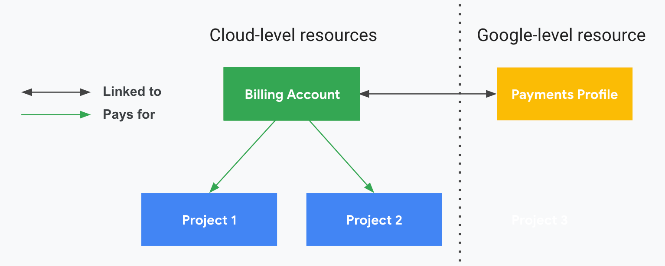
Figure 4.1.1. Billing Account and Payments Profile relationship example

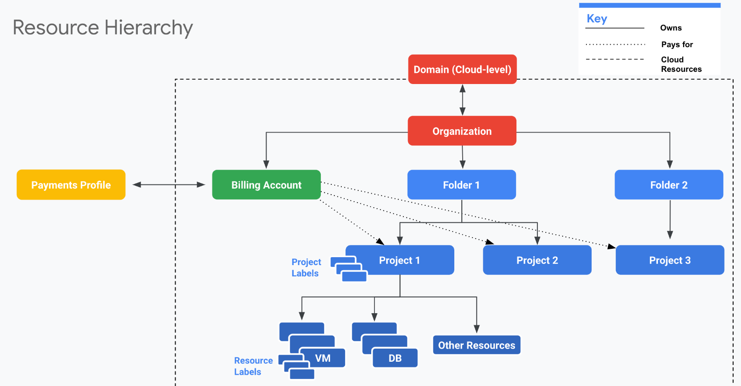
Figure 4.1.2. Billing and Resource Hierarchy relationship example
1. Partner-Managed Billing (Recommended for Enterprise)
- Work with an authorized Google Cloud partner/reseller who manages the billing account on behalf of the City
- The partner creates a billing subaccount under their reseller parent billing account
- Benefits: Partner provides ongoing support, handles invoicing, may offer additional services and consolidated billing
- The City retains control over projects and resources while the partner manages billing operations
2. Self-Managed Billing Account
- The City creates and manages its own Cloud Billing account directly with Google
- Two sub-options available:
  - Self-serve account: Uses credit/debit card for automatic payments (suitable for smaller deployments)
  - Invoiced billing: Monthly invoices for larger organizations (requires eligibility approval and typically higher spending thresholds)

Key Considerations to Add:
- Partner route: Better for organizations wanting managed services, consolidated billing, or lacking internal Google Cloud billing expertise
- Self-managed route: Provides direct control but requires internal resources to manage billing, payments, and account administration
- The City can migrate from self-managed to partner-managed (or vice versa) later if needed, though this requires coordination
Both options provide full access to Google Cloud services. The choice depends on the City's internal procurement processes, finance team capacity, and preference for direct management versus partner support."

  - Budget alerts overview and design
Cloud Billing budgets can monitor all of Google Cloud charges in one place. It enables tracking of actual Google Cloud spending against planned spending. After a budget amount is set, budget alert threshold rules can be set to trigger email notifications in case the planned budget is exceeded. With Cloud Billing budgets, the following options can be configured to track budget alerts:
- Time period of budget
- Scope of budget
- Specified budget total amount or based on previous calendar period
- Threshold which alert is triggered
- Recipients of email alerts
- Pub/Sub for programmatic notifications
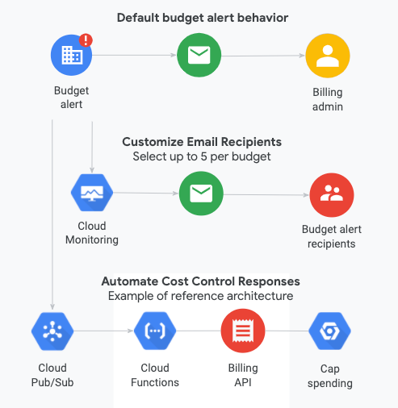
Figure 6.2.1. Billing Budget Alert behavior visualized.

For the landing zone, the following design will be implemented. Table 6.2.2. showcase a template for the budget alerts that will apply to all projects in an organization while Table 6.2.3. lists for the budget alert. Please note, the recipient billing_admin@calgary.ca, which is the Billing Admin, will be notified when the budget is exceeded. To add new projects to an existing budget alert, one can edit an existing budget alert configuration after it has been created.
Implementation of budget alerts is managed through terraform <Github URL>
Table 6.2.2. Budget Alert configuration template
Configuration Template | Value
Time period of budget | 1 Calendar Period (end of each month)
Scope of budget | Projects under each department
Budget total amount | Last month’s spend
Threshold which alert is triggered | 75%, 90%, 100%, 120%
Recipients of email alerts | Billing Admins
Pub/Sub for programmatic notifications | Not used

Table 6.2.3. Budget Alert configurations
Budget Alert Name | Initial budget alert projects | Recipients
Ba-coc-organization-lastmonthspend | All projects inside the organization | Billingadmin_gp@calgary.ca

  - Billing exports
Cloud Billing export to BigQuery enables detailed Google Cloud billing data (such as usage, cost estimates, and pricing data) to be exported automatically throughout the day to a BigQuery dataset. The Cloud Billing data from BigQuery can then be accessed for detailed analysis or visualized using a tool like Google Data Studio. Once billing has been set up, the city of Calgary will set up standard and pricing billing export to a BigQuery dataset located in prj-coc-billing for analysis.

Table 6.3.1. Billing export configuration design
BigQuery dataset | Billing account to be exported
Bq-coc-organization-billing | XXXXX-XXXXX-XXXXX

- Resource Hierarchy
  - Organization & resources hierarchy overview
The organization resource is the root node of the Google Cloud resource hierarchy, which consists of folders, projects, and resources. It defines the shape and use of Google Cloud services within an organization. Policies are inherited from top to bottom and cannot be altered by resource owners who are lower in the hierarchy. A good hierarchy can allow production and non-production environments to be hosted under the same organization and have folders perform the restrictions necessary to secure all elements.
Table 7.1.1 Root Node
Organization Name | Description
calgary.ca | This is the domain used to identify the organization within GCP. It is not visible outside the platform and only used for authentication of users accessing the infrastructure.

Benefits of the Organization resource
- With an organization resource, projects belong to the City of Calgary organization instead of the employee who created the project.
- Organization administrators have central control of all resources.
- Can grant roles at the organization level, which are inherited by all projects and folders under the Organization resource.
Folders are used as a method of grouping projects into related groups. Security policies can be applied and access permissions at the folder level; these policies and permissions are inherited by resources within the folder structure.
Table 7.1.2 Folder Name
Folder Name | Description
fldr-coc-dev | Folder for the Development environment which will contain subfolders for applications
fldr-coc-shared | Hosts all shared services. This folder will contain logging, VPC, Monitoring, Billing projects, it acts as a folder for logical groupings of services shared across the cloud landing zone.
fldr-coc-boostrap | Hosts the projects for the IaC service accounts and Storage buckets
fldr-coc-prod | This folder will contain projects for Client for the User production environment
fldr-coc-qa | This folder will contain projects for Client for the User Acceptance Test environment
fldr-coc-sandbox | This folder will contain projects for Client Proof of concept/ applications

Projects contain cloud resources. Each project inherits the policy of the parent folder or folders and of the Google Cloud organization. APIs can be enabled or disabled within each project to support the services that are needed for that project. Each project is associated with a billing account. For example:
- Host project (Shared) contains the Shared VPC networks.
- Service projects are attached to a Shared VPC host project. Service projects are used by the City of calgary for production, non-production, and development.
Table 7.1.3 Project Name
Project name | Purpose
prj-coc-bootstrap-iac | Initial landing zone deployment project
prj-coc-billing | Stores billing logs, billing related BigQuery datasets and other billing related resources
prj-coc-log-monitor | Hosts log storage buckets for all projects and Monitoring Dashboard
prj-coc-shared-nethub | Hosts shared VPC networks, Firewall
prj-coc-dev-app-01 | Hosts Client Dev Environment Application

  - Naming conventions
A good naming convention should be in place before creating any Google Cloud resources. A naming convention ensures that all the resources will have a predictable name, which helps lower the administrative burden associated with management of those resources.
Table 7.2.1 describes recommended conventions for creating Google Cloud element names for the city of calgary. landing zone architecture.

Environment Codes
prd | Production | Live production environment
stg | Staging | Pre-production testing
uat | UAT | User acceptance testing
dev | Development | Development environment
tst | Test | Testing environment
sbx | Sandbox | Experimental/sandbox

Common Resource Abbreviations
vm | Compute Engine VM
vpc | VPC Network
gke | Google Kubernetes Engine
run | Cloud Run
func | Cloud Functions
gae | App Engine
bkt | Cloud Storage Bucket
fs | Filestore
mysql | Cloud SQL MySQL
pgsql | Cloud SQL PostgreSQL
bt | Bigtable
bq | BigQuery
pubsub | Pub/Sub
df | Dataflow
lb | Load Balancer
fw | Firewall Rule
nat | Cloud NAT
vpngw | VPN Gateway
eip | External IP
psc | Private Service Connect
sa | Service Account
kms | Cloud KMS
sm | Secret Manager
ar | Artifact Registry
ig | Instance Group
mig | Managed Instance Group
snap | Snapshot

GCP Component | GCP Naming Convention | GCP Example | Explanation | GCP Naming Constraints
Compute Engine VM | env-workload-vm-instance | prd-dc-vm-01 | Production, Domain Controller, VM, Instance | Lowercase, hyphens, 1-63 chars, start with letter
Persistent Disk (Boot) | vmname-boot-instance | prddc01-boot-01 | VM Name, Boot Disk, Instance | Lowercase, hyphens, 1-63 chars
Persistent Disk (Data) | vmname-data-instance | prddc01-data-01 | VM Name, Data Disk, Instance | Lowercase, hyphens, 1-63 chars
Instance Group | env-workload-ig-instance | prd-dc-ig-01 | Production, Workload, Instance Group, Instance | Lowercase, hyphens, 1-63 chars
Managed Instance Group | env-workload-mig-instance | dev-cmg-mig-01 | Development, Workload, MIG, Instance | Lowercase, hyphens, 1-63 chars
VPC Network | env-workload-vpc-instance | dev-synapse-vpc-01 | Development, Function, VPC, Instance | Lowercase, hyphens, 1-63 chars
VPC Subnet | env-workload-subnet-region | dev-synapse-subnet-cc | Development, Function, Subnet, Region (cc=canada-central) | Lowercase, hyphens, 1-63 chars
Cloud VPN Gateway | env-workload-vpngw-instance | dev-synapse-vpngw-01 | Development, Function, VPN Gateway, Instance | Lowercase, hyphens, 1-63 chars
External IP Address | env-workload-eip-instance | dev-synapse-eip-01 | Development, Function, External IP, Instance | Lowercase, hyphens, 1-63 chars
VPN Tunnel | env-workload-tunnel-target | prd-synapse-tunnel-onprem | Production, Function, Tunnel, Target | Lowercase, hyphens, 1-63 chars
External VPN Gateway | env-workload-peergw-instance | prd-synapse-peergw-01 | Production, Function, Peer Gateway, Instance | Lowercase, hyphens, 1-63 chars
Cloud Router | env-workload-router-instance | dev-managed-router-01 | Development, Function, Router, Instance | Lowercase, hyphens, 1-63 chars
Firewall Rule | env-workload-fw-direction-action | dev-web-fw-ingress-allow | Development, Workload, FW, Direction, Action | Lowercase, hyphens, 1-63 chars
Cloud Load Balancing | env-workload-lb-instance | dev-ecomm-lb-01 | Development, Function, Load Balancer, Instance | Lowercase, hyphens, 1-63 chars
Cloud NAT | env-workload-nat-instance | dev-synapse-nat-01 | Development, Function, NAT, Instance | Lowercase, hyphens, 1-63 chars
Private Service Connect | env-workload-psc-instance | dev-database-psc-01 | Development, Function, PSC, Instance | Lowercase, hyphens, 1-63 chars
Cloud DNS Zone | env-workload-dns-instance | dev-internal-dns-01 | Development, Function, DNS, Instance | Lowercase, hyphens, 1-63 chars
Cloud CDN | env-workload-cdn-instance | dev-csc-cdn-01 | Development, Function, CDN, Instance | Lowercase, hyphens, 1-63 chars
Cloud Storage Bucket | env-workload-bkt-instance | prdsynapsebkt01 | Production, Workload, Bucket, Instance | Globally unique, 3-63 chars, lowercase, no underscores
Filestore | env-workload-fs-instance | dev-app-fs-01 | Development, Function, Filestore, Instance | Lowercase, hyphens, 1-63 chars
Cloud SQL (MySQL) | env-workload-mysql-instance | dev-c3m-mysql-01 | Development, Function, MySQL, Instance | Lowercase, hyphens, 1-98 chars
Cloud SQL (PostgreSQL) | env-workload-pgsql-instance | dev-app-pgsql-01 | Development, Function, PostgreSQL, Instance | Lowercase, hyphens, 1-98 chars
Cloud SQL (SQL Server) | env-workload-sqlserver-instance | dev-remedy-sqlserver-01 | Development, Function, SQL Server, Instance | Lowercase, hyphens, 1-98 chars
AlloyDB | env-workload-alloydb-instance | dev-analytics-alloydb-01 | Development, Function, AlloyDB, Instance | Lowercase, hyphens, 1-63 chars
Spanner | env-workload-spanner-instance | dev-global-spanner-01 | Development, Function, Spanner, Instance | Lowercase, hyphens, 2-30 chars
Firestore | env-workload-firestore | dev-app-firestore | Development, Function, Firestore | Project-level, single database per mode
Bigtable | env-workload-bt-instance | dev-iot-bt-01 | Development, Function, Bigtable, Instance | Lowercase, hyphens, 6-33 chars
Memorystore (Redis) | env-workload-redis-instance | dev-cache-redis-01 | Development, Function, Redis, Instance | Lowercase, hyphens, 1-40 chars
BigQuery Dataset | env_workload_dataset | prd_synapse_analytics | Production, Workload, Dataset | Lowercase, underscores, 1-1024 chars
Dataproc Cluster | env-workload-dataproc-instance | dev-synapse-dataproc-01 | Development, Function, Dataproc, Instance | Lowercase, hyphens, 1-55 chars
Pub/Sub Topic | env-workload-topic-instance | dev-iot-topic-01 | Development, Function, Topic, Instance | 3-255 chars, start with letter
Pub/Sub Subscription | env-workload-sub-instance | dev-iot-sub-01 | Development, Function, Subscription, Instance | 3-255 chars, start with letter
Dataflow Job | env-workload-df-instance | dev-etl-df-01 | Development, Function, Dataflow, Instance | Lowercase, hyphens, 1-40 chars
Cloud Composer | env-workload-composer-instance | dev-orchestration-composer-01 | Development, Function, Composer, Instance | Lowercase, hyphens, 1-63 chars
Cloud Run Service | env-workload-run-instance | dev-api-run-01 | Development, Function, Cloud Run, Instance | Lowercase, hyphens, 1-63 chars
Cloud Functions | env-workload-func-instance | dev-integration-func-01 | Development, Function, Cloud Functions, Instance | Lowercase, hyphens, 1-63 chars
App Engine | env-workload-gae | dev-web-gae | Development, Function, App Engine | Project-level service
Workflows | env-workload-workflow-instance | dev-invoiceupload-workflow-01 | Development, Function, Workflow, Instance | Lowercase, hyphens, 1-64 chars
Cloud Scheduler | env-workload-scheduler-instance | dev-backup-scheduler-01 | Development, Function, Scheduler, Instance | Lowercase, hyphens, 1-500 chars
Cloud Tasks | env-workload-tasks-instance | dev-async-tasks-01 | Development, Function, Tasks, Instance | Lowercase, hyphens, 1-100 chars
GKE Cluster | env-workload-gke-instance | dev-microservices-gke-01 | Development, Function, GKE, Instance | Lowercase, hyphens, 1-40 chars
Artifact Registry | env-workload-ar-instance | dev-images-ar-01 | Development, Function, Artifact Registry, Instance | Lowercase, hyphens, 1-63 chars
Vertex AI Workbench | env-workload-vertexai-instance | dev-ml-vertexai-01 | Development, Function, Vertex AI, Instance | Lowercase, hyphens, 1-63 chars
Cloud Vision API | N/A (API-based) | N/A | API service, no resource naming | API-based service
Cloud Natural Language | N/A (API-based) | N/A | API service, no resource naming | API-based service
Speech-to-Text | N/A (API-based) | N/A | API service, no resource naming | API-based service
Dialogflow | env-workload-dialogflow-instance | dev-chatbot-dialogflow-01 | Development, Function, Dialogflow, Instance | Lowercase, hyphens
Secret Manager Secret | env-workload-secret-name | dev-api-secret-dbpassword | Development, Function, Secret, Name | Lowercase, hyphens, 1-255 chars
Cloud KMS Key Ring | env-workload-keyring-instance | dev-encryption-keyring-01 | Development, Function, Key Ring, Instance | Lowercase, hyphens, 1-63 chars
Cloud KMS Key | env-workload-key-purpose | dev-storage-key-encrypt | Development, Function, Key, Purpose | Lowercase, hyphens, 1-63 chars
Service Account | env-workload-sa@project.iam | dev-app-sa@myproject.iam.gserviceaccount.com | Development, Workload, SA @ Project | 6-30 chars before @
IAM Role | roles/service.roleName | roles/storage.objectViewer | Service, Role Name | Predefined or custom roles
Cloud Monitoring Workspace | env-workload-monitoring-instance | dev-infra-monitoring-01 | Development, Function, Monitoring, Instance | Project-scoped
Cloud Logging Log Sink | env-workload-sink-instance | dev-audit-sink-01 | Development, Function, Sink, Instance | Lowercase, underscores, 1-100 chars
Cloud Trace | N/A (Automatic) | N/A | Automatic tracing | Project-scoped, automatic
GCP Project | env-bu-workload-prj | prd-it-network-prj | Production, Business Unit, Function, Project | 6-30 chars, globally unique ID
GCP Folder | env-bu-folder | prd-it-folder | Production, Business Unit, Folder | Display name, 1-30 chars
GCP Organization | domain.com | mycompany.com | Domain-based organization | Tied to Cloud Identity domain
Backup Plan | env-workload-backup-instance | dev-vm-backup-01 | Development, Function, Backup, Instance | Lowercase, hyphens
Snapshot | env-workload-snap-timestamp | dev-db-snap-20241215 | Development, Function, Snapshot, Timestamp | Lowercase, hyphens, 1-63 chars
Custom Image | os-version-workload-instance | ubuntu2204-web-01 | OS, Version, Workload, Instance | Lowercase, hyphens, 1-63 chars

Resource | Naming Convention | Example
Folder | fldr-environment | fldr-prod
Project | prj-environment-internal/external business unit | prj-prod-int-it
VPC | environment-workload-resource-instance | prod-synapse-vpc-01
Subnet | environment-workload-resource-instance | prod-synapse-subnet-01
Firewall | fw-{vpc-name}-priority-direction-action-src-label-dest-label-protocol-port-{firewall-label} | Fw-prod-shared-base-1000-i-a-all-all-tcp-80
Cloud Router | cr-{vpc-name}-region{-cloud-router-label} | cr-prod-shared-base-us-east1-cr1
Route | rt-{vpc-name}-priority-instance-tag-next-hop-{route-label} | Rp-prod-shared-base-1000-all-default-windows-activation
Cloud Interconnect connection | ic-source-destination-coloation | Ic-dal-lga-zone1-1422
Cloud Interconnect VLAN attachment | vl-ic-name-cr-name | Vl-dal-da1-zone1-p-shared-base-us-east1-cr1
Group | Grp-business-group-label | Grp-gcp-billing-admin
Role | Rl-function-{role-label} | Rl-compute-admin
VPN gateway | Vgate-Business-“src_env”-“dest_env”-region-VPNgateway | Vgate-coc-onprem-staging-USEAST1-vpngateway
VPN tunnel | Vtun-Business-“src_env”-“dest_env”-region-VPNtunnel-{type of VPN}-label | Vtun-coc-onprem-staging-USEAST1-vpntunnel-classic-1
BudgetAlert | Ba-Business-scope-type | Ba-coc-organization-lastmonthspend
BigQuery dataset | Bq-Business-environment-purpose | Bq-coc-shared-billing
GKE | Gke-Business-environment-region | Gke-coc-staging-USEAST1
Log Router | LS-Business-environment-region | LS-coc-POC-USWEST2
Logging Storage Bucket | Lsb-Business-"bucket _Business"-"logging_scope"-"types_of_logs" | Lsb-coc-shared-organization-alllogs
Service Account | sa-{service-account}-label | sa-bkt-reader
Storage Bucket | bkt-project-name-{bucket-label} | bkt-coc-POC-data

  - Labels
GCP leverages labels to organize resources. Labels provide additional information about resources such as resource owner, billing owner, or other essential properties not available within the resource name. Labels are defined through a key:value pair where the key is a constant such as Team while the value is the variable such as Finance.
While each resource type may have specific labeling requirements, a mandatory set of labels will be enforced for all resources. To improve accuracy and reduce maintenance of labels, transient data such as usernames or emails are not used. The following table defines the mandatory labels for all resources.
The below table lists the mandatory label keys that will be provisioned with any resource deployment. Reference Appendix B for predefined Label values

Resource | Naming Convention
company | Defines the company which owns the specified resource. Currently the only company is COC
csp | Defines the CSP where this resource is deployed which is gcp
costcenter | The cost center / cost code associated with this resource
changetracking | Latest change ticket number associated with the provisioning or modification of the resource
applicationid | Identify resources that are related to a specific application
environment | Denotes the environment where the specified resource resides (PROD, TEST, DEV..etc)

  - Resource hierarchy design
To design an efficient and secure GCP organization structure for the City of Calgary, a clear hierarchy of resources will be established to prevent accidental deletion or updates to resources outside of their intended scope. The following GCP Organization hierarchy was designed as shown in Figure 7.4.1. Under the root organization, calgary.ca, five separate folders will be created, bootstrap, seed,billing, dev and Prod.. Table 7.4.2. reflect the purpose of each project to ensure their use case is fully understood.
Table 7.4.2. Breakdown of each landing zone project’s purpose in calgary.ca organization
Project name | Purpose
Prj-COC-Bootstrap  Prj-COC-seed | Bootstrap Project is created first (often manually or with minimal automation)  Seed Project is created by or alongside the bootstrap project
Prj-COC-Billing-logs | Stores billing logs, billing related BigQuery datasets and other billing related resources
Prj-COC-Log-Monitor | Hosts log storage buckets for all projects and Monitoring Dashboard
In GCP landing zone architecture, these are foundational projects that enable infrastructure-as-code (IaC) deployment and centralized management:
Bootstrap Project (Prj-COC-Bootstrap)
- The initial project created to kickstart your GCP organization setup
- Contains the automation tooling and state management for deploying other infrastructure
- Stores Terraform state files (typically in Cloud Storage buckets)
- Hosts service accounts with permissions to create and manage other projects
- Contains CI/CD pipelines (Cloud Build triggers, etc.)
Seed Project (Prj-COC-Seed)
- Acts as the "factory" for provisioning other projects and resources
- Contains the service accounts that actually execute Terraform/IaC deployments
- These service accounts are granted organization-level permissions to create projects, assign IAM roles, and manage resources across the organization
- Typically more restricted and secured than the bootstrap project
Billing (Prj-COC-Billing-Logs)
- This project will have bigquery datasets which will autoupdated every day with new billing exports from GCP.
Logging/Monitoring(Prj-COC-Log-Monitor)
- This contains centralized logging cloud storage buckets and sinks for PUB/SUB to export to sentinel
- This project also contains a centralized monitoring workspace.
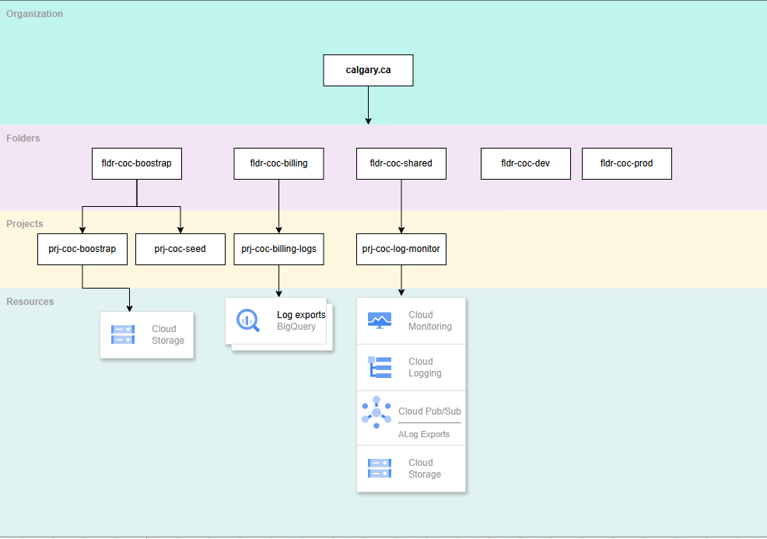
Figure 7.4.1. City of Calgary GCP Landing zone design
  - Organization policies implementation
To improve organization security and process uniformity, certain organization policies were placed on City of Calgary resource hierarchy at the organization level to enforce certain restrictions. Table 7.5.1 contains a list of organization policies placed on City organization with reasonings attached.

Table 7.5.1. Organization Policies to be added for City of Calgary
Organization Policy | Description | Reasoning | Scope
Restrict shared VPC project lien removal | Restrict shared VPC project lien removal, which prevents the shared VPC project from being deleted unless a user is authorized by this policy. | This policy prevents the shared VPC project from accidentally or maliciously deleted. | Organization
Skip default network creation | Skips the creation of default network when a project is created | Prevents creation of default networks which assigns a subnet for each region. A subnet for each region is unnecessary and adds additional management overhead. | Organization
Domain Restricted Sharing | This list constraint defines one or more Cloud Identity or Google Workspace customer IDs whose principals can be added to IAM policies. | Constrains a list of members which can be added to your organization's IAM policy. | Organization
Restrict VPN Peer IPs | Constrains a set of valid IPv4 addresses which VPN peering can be established. | Prevents unauthorized VPN peering from IPv4 addresses not listed in the organization policy. | Organization
Enforce Public Access Prevention | When enforced, this policy prevents public access to your GCS storage buckets. | By preventing public access to GCS buckets, data is kept safe from unauthorized downloads. | Organization
For a complete list of organization policies refer this <excel sheet>
Implementation of ORG policies is done through terraform code
- Networking
  - Regions
To comply with data residency requirements (data must remain in Canada), and considering cloud services availability, northamerica-northeast1 (NANE1) is selected as the primary region for City of Calgary GCP landing zone. At the time of writing, less services are available in northamerica northeast2 (NANE2), and therefore will be used as the DR region.
Zone
northamerica-northeast1-a | Primary zone for workload
northamerica-northeast1-b / northamerica-northeast1-c | Primary/Secondary zone for HA deployments
northamerica-northeast2-a | Primary zone for workload (DR)
northamerica-northeast2-b / northamerica-northeast2-c | Primary/Secondary zone for DR deployments

  - Network Configuration
Based on the City of Calgary's operational requirements, establishing networking components within Google Cloud Platform (GCP) is not necessary. The organization primarily utilizes Software-as-a-Service (SaaS) offerings, such as Google Maps API and similar cloud-based services, which do not require dedicated network infrastructure.
For this engagement, City of Calgary will not implement any network configuration in any shared VPC due to a lack of specific requirements.
  - External IP Requirements
The City of Calgary has no requirement for external IP’s at this time. However, there are multiple options for procuring external IP’s within the GCP environment. GCP supports a Bring Your Own IP (BYOIP) process if public facing IPs need to be migrated to GCP or GCP provided IP’s. External IP addresses are only to be applied to external facing Load Balancers. No external IP’s are permitted to be attached to any internal resources (This will be applied as part of an organization level policy). IP’s issued to External Load Balancers are issued from GCP’s pool of available IP’s and attached to a project until released
  - Cross-project communication
Communication between projects will be allowed only if application connectivity is required. No implicit connectivity between environments and projects or applications will be allowed without explicit approval.
All communication between environments and on-premises is routed through the Hub Spoke (Shared Services VPC) with no routing between environments (Sandbox/Dev/NonProd/Prod). If direct connectivity is required between spokes, a peering can be established between the spokes and new firewall rules applied to allow the required traffic.
  - VPC design
The City of Calgary currently does not have requirements to provision networking resources like VPC, Firewall at this stage
Table 8.5.1. CIDR Blocks for subnets in the Shared VPC
Subnet Name | Region | Primary Subnet IP
TBD | TBD | TBD
  - VPN design
For this engagement, City of Calgary will not implement any firewall policies in any shared VPN due to a lack of specific policies to apply.
 | GCP VPN Gateway IP address | OnPrem VPN Gateway IP Address
Primary | TBD | TBD
For this engagement, City of Calgary will not implement any VPN connectivity from on-prem to GCP

- Monitoring and Logging
  - Cloud monitoring overview and design
Cloud Monitoring populates monitoring dashboards based on services and resources an organization uses. Custom dashboards can also be created to chart data, display indicators, or display text for specific resources or services. There are several metrics monitored by Cloud Monitoring:
- System metrics that Google Cloud services generate. These metrics provide information about how the service is operating. For example, Compute Engine reports more than 25 unique metrics for each virtual machine (VM) instance.
- System and application metrics that the Cloud Monitoring agent gathers.
- Custom metrics that your service writes by using the Cloud Monitoring API or by using a library like OpenCensus.
- Logs-based metrics, which collect numeric information about the logs written to Cloud Logging.
By default, Cloud Monitoring pages in the Google Cloud Console provide access only to the time series stored in the scoping project. The scoping project is the project that is selected with the Cloud Console project picker, it is the project the user is currently in. The scoping project stores the alerts, uptime checks, dashboards, and monitoring groups for monitored projects that an organization chooses.

  - Cloud logging overview and design
Cloud Logging is part of Google Cloud's operations suite of products. It includes storage for logs, a user interface called the Logs Explorer, and an API to manage logs programmatically. Logging allows a user or an application to read and write log entries, query logs, and control routing, storage, and programmatic use of generated logs. In Cloud Logging, all logs, including audit logs, platform logs, and user logs, are sent to the Cloud Logging API where they pass through a Logs Router, also known as log sink. The Logs Router checks each log entry against existing rules to determine which log entries to discard, which log entries to ingest (store) in Cloud Logging, and which log entries to route to supported destinations using log sinks. There are 4 categories of Logs:
- Google Cloud Platform Logs: Google Cloud platform logs are service-specific logs that can help debug and troubleshoot issues, as well as better understand the Google Cloud services being used. Examples include GKE workload CPU usage or VPC flow logs.
- User-written logs: User-written logs generated by either the logging agent, the Cloud Logging API, or the Cloud Logging client libraries. User-written logs contain information related to their custom applications and services.
- Security Logs: Two kinds of security related logs, cloud audit logs and access transparency logs
  - Audit Logs: 4 types of audit logs to help monitor activities and access within your Google Cloud Project
    - Admin Activity audit logs
    - Data Access audit logs
    - System Event audit logs
    - Policy Denied audit logs
  - Access Transparency Logs: Logs of actions taken by Google staff
- Multi-cloud and Hybrid Cloud Logs: Cloud Logging can ingest logs arriving from other cloud services providers, including Microsoft Azure and Amazon Web Services (AWS). These logs are called "multi-cloud" logs.
Logs can be stored in the following resources in a project
- Cloud Logging bucket
- BigQuery Dataset
- Cloud Storage Bucket
- Cloud Pub/Sub Topic
- Splunk
An aggregated sink is a type of log sink that combines and route log entries from Google Cloud resources contained by an organization or folder. For example, an organization admin might aggregate and route audit log entries from all the folders contained by an organization to a Cloud Storage bucket for analysis later on.
For the landing zone project, an aggregated sink will be created for the City of Calgary at ORG level to collect logs with severity warning or above for all resources within all environments. The configuration for the aggregated log sinks to be created is listed in Table 7.2.1.

Table 9.2.1. Log sink configurations for each department
Sink name | Sink scope | Sink destination type | Sink destination Project | Sink destination region | Logs to include
ls-coc-org-sink | ORG | Cloud Logging bucket | prj-coc-shared-log-monitor | northamerica-northeast1 | Severity >= WARNING
Implementation of logging sinks is done through terraform code

  - Cloud Logs Collection
All activities on the GCP infrastructure level as well as the services level will generate logs that are collected by Google Cloud Operations Suite and routed using different sinks (GCP’s solution for configuring log routing). To enable a logging posture that is both flexible and governed the logging routing will be configured as follows:
Every project provisioned will host 2 default log buckets (_Default and _Required) to store logs.
  - o _Default will hold platform logs for 30 days on a rotating basis to enable project owners troubleshooting.
  - o _Required will hold audit logs for 400 days (not modifiable) for audit purposes
  - All provisioned projects will route both platform and audit logs to a centralized storage location (separately for each environment). This will enable long term retention of platform logs (1 Month or 12 Months) and restricted access audit logs (400 Days). Access to the centralized logs will be granted to authorized users only (this can be determined at a later date).
  - Logs Export
Audit logs are exported through Cloud Pub/Sub to Azure Sentinel to enable a centralized view of a multi-cloud security incident reporting. Audit export will be set up by default on all projects provisioned.

- Infrastructure as Code (IaC)
Infrastructure as Code (IaC) is the management of infrastructure (networks, virtual machines, load balancers, connection topology) in a descriptive model, using the same versioning as the DevOps team uses for source code. Like the principle that the same source code generates the same binary, an IaC model generates the same environment every time it is applied. To simplify management of the future landing zone, it was selected as the approach to build the GCP infrastructure.
  - Repositories
Our main repos GCP landing code will be hosted on Github URL link,
It is recommended to create a separate repos for other Infrastructure deployments to deploy a decoupled infrastructure where only a certain layer can be changed/modified without affecting core infrastructure components that are required for operation i.e. network backbone, firewalls, etc.

- Security
  - Security command center overview
Security Command Center (SCC) is Google Cloud's centralized vulnerability and threat reporting service. Security Command Center helps an organization strengthen its security posture by evaluating its security and data attack surface; providing asset inventory and discovery; identifying misconfigurations, vulnerabilities, and threats; and helping mitigate and remediate risks.

There are two tiers to Security Command Center, standard tier, and premium tier. Table 8.1.1 Summarizes the difference between the two tiers.

Table 11.1.1. Difference between standard and premium tier of GCP SCC
Standard tier features | Premium tier features
- Security health analytics  - Web Security Scanner custom scans  - Support for granting IAM roles at the organization level  - Access to integrated GCP services including:  - Cloud Data Loss Prevention (DLP)  - Google Cloud Armor  - Anomaly Detection  - Integration with Forseti Security, a third-party security information and event management (SIEM) application | - Event threat detection that uses threat intelligence and machine learning  - Container threat detection  - Security Health analytics  - Web security scanner  - Support for IAM grants at the organization, folder, and project level  - Continuous export of new findings to pubsub  - VM manager vulnerability reports

For a full list of differences visit the official GCP documentation on SCC tiers. For this engagement, City of Calgary will enable the standard tier features since there are no costs associated with the standard tier.

- Acronyms
Acronym | Name
BGP | Border Gateway Protocol
GA | General Availability
GCP | Google Cloud Platform
GCE | Google Compute Engine
HA | High Availability
IAM | Identity Access Management
IDAAS | Identity as a service
idP | Identity Provider
IAAC / IAC | Infrastructure as Code
MFA | Multi Factor Authentication
POC | Proof of Concept
SAML | Security Assertion Markup Language
SCC | Security Command Center
TBD | To be determined
VM | Virtual Machine
VPC | Virtual Private Cloud
VPN | Virtual Private Network
COC | City of Calgary

- Acknowledgement of Implementation
City of Calgary. acknowledges implementation of the above designs to City of Calgary GCP Business(s).
City of Calgary
BY: | _______________________________________________  (AUTHORIZED SIGNATURE)
PRINT: | _______________________________________________
TITLE: | _______________________________________________
DATE: | _______________________________________________

